For financial advisers only
Use your ISA allowance – 2025/26 tax year – sample text for ARC
If you decide to use any of the following sample text, you must make sure that it meets your regulatory requirements. We don’t accept liability for any consequences resulting from its use.
Here’s an example of the kind of communication you could send to clients who have unused ISA allowance and would like to top up their ISA on Aegon Retirement Choices (ARC).
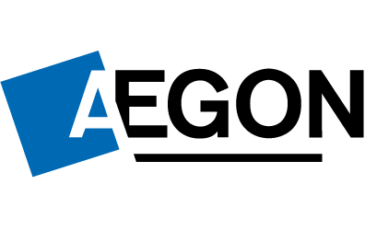
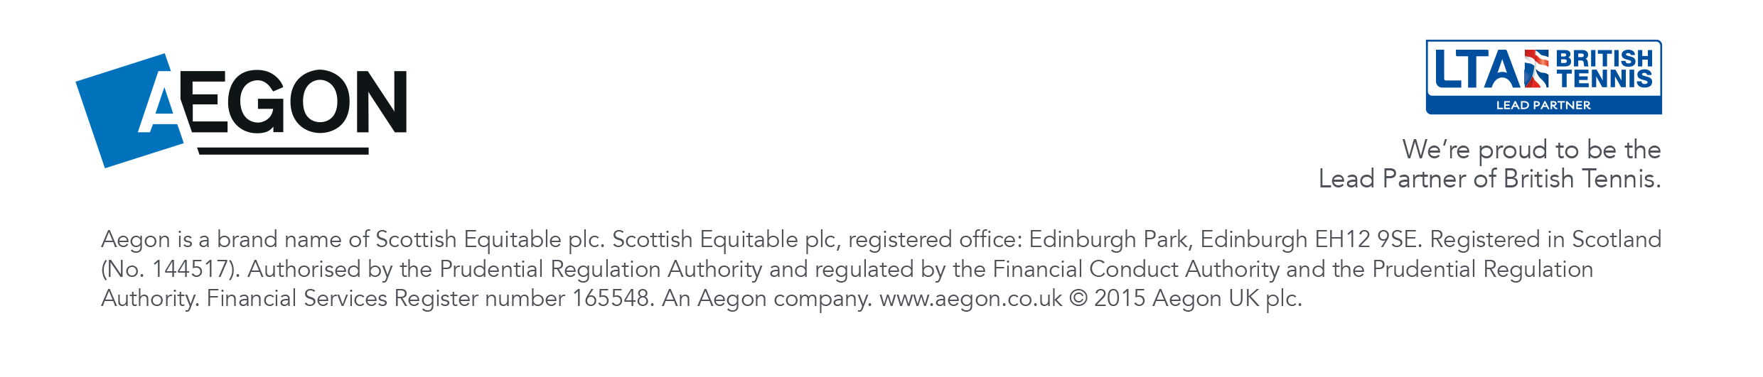
RTL375983 04/25

Dear <insert name>
Make the most of this year’s ISA allowance and top up your Aegon stocks and shares ISA.
The 2025/26 ISA allowance of £20,000 is available to use until 5 April 2026 and you have remaining ISA allowance of £<XXXX>.
Your Aegon ISA is a flexible ISA. Flexible ISA rules allow you to withdraw and replace money from this ISA in the same tax year without losing any of your tax-free allowance. Any amount you withdraw, including any income from investments paid to your bank account, will be added to the remaining amount you can invest in this tax year.
The value of investing in a stocks and shares ISA
As you already have an Aegon ISA you’ll be aware it’s a tax-efficient way to invest, with any income or growth you receive free of any personal liability to capital gains tax and income tax.
Historically, investing in stocks and shares has provided the potential for greater returns over the long term (more than five years) than keeping your money in the bank – although of course, past performance isn’t a reliable guide to what will happen in the future.
It’s important to remember that unlike money in the bank, investing in stocks and shares puts your money at risk. The value of your investment can fall as well as rise, and you could get back less than you invest.
Also, although there’s no fixed term, as the value of investments can fall you should be prepared to hold an investment in the Aegon ISA for at least five years – ideally longer. Finally, the favourable tax treatment of ISAs might not be maintained in the future and is subject to change. The benefit of the tax efficiency will depend on your individual circumstances.

Keep investing in the same fund, or choose another to invest in
You’re currently invested in the <XXXXX> fund(s) and if you’re happy with this fund(s), we’ll arrange to put your top up money into the same fund(s).
Alternatively, you can choose a different fund(s) to invest in.

If you want to make the most of your tax-efficient ISA allowance by topping up your Aegon ISA, please call us on <XXXX XXX XXXX> and we’ll be happy to help.

Yours sincerely

<Consultant Name>
<Company Name>

