This communication is for employers only. It mustn’t be distributed, or relied on by members.
Scheme announcement email – sample email copy: Aegon Master Trust schemes only
To help you communicate your new Aegon workplace pension to your employees, we’ve produced this sample copy for you to use. If you adapt or remove elements of this text we can’t be held responsible for any consequences arising from doing so.
We’ve taken all reasonable care to make sure the information it contains is accurate at the time we’ve issued it, but we don’t accept liability for any consequences resulting from its use.
There are certain rules you must follow when promoting your company pension scheme to your employees. You can find out more about these in the regulator’s guidance for employers.
If you’re not sure if it’s suitable for your purposes, please get in touch with your financial adviser.
Please note this copy should only be used for Aegon Master Trust schemes only and not contract based schemes.

TP392452 04/22

Your <ABC> workplace pension with Aegon
We want to help make sure you’re all set up for your life after you stop working.
That’s why, after reviewing our current <plan/scheme>, we’ve decided to move your workplace pension to Aegon. This is your retirement savings, it’s important you manage and keep track of them.
How will this benefit you?
- We've negotiated competitive pension charges with Aegon on your behalf.
- You’ll be able to view and manage your workplace retirement savings online and on Aegon’s app.
- Aegon's digital tools will help you see if your retirement savings are on track.
- They have lots of useful guides and videos to help you learn more about pensions and make informed decisions.
- There’s also tools and support to help you manage your financial wellbeing and the way you feel about your money.

What happens next?
- Your pension contributions will start being paid into your new account from <date>
- You’ll be able to activate your online account once you have received your welcome letter which is due to be sent <date>
Keeping track has never been easier
You’ll be able to view and manage your workplace retirement savings from an easy to use online account.
Once you become a member of the <plan/scheme> you’ll be sent details on how to active your online account. You’ll be able to:
- Sign in securely on any device, at any time. Manage and switch your investments in one place.
- Make and track your transactions.
- Access digital documents and valuations.
- View your savings on the move with the Aegon App – you’ll get access once you become a member and have activated your online account.

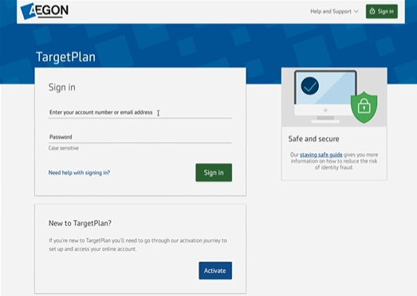
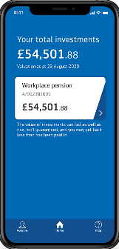

How can I find out more?
Aegon have created lots of useful information to help you understand your workplace pension.
You can start by watching this short video below which talks you through the benefits of your workplace pension and then visiting their member hub to learn more.
