Eventbrite Access & Event Creation Process

1. Initial Access Setup
To request access contact eventops@Aegon.co.uk , further details can be found on the digital standards page.
Users are invited as Basic Event Creators by admin team.
Important Note:
When accessing Eventbrite for the first time via the invitation link, you may encounter an “Access Denied” message.
Simply close the browser and try again — access should work on the second attempt.
Video recordings of Eventbrite process

2. Navigating Eventbrite
Once access is successful:
Use the Events tab to view all current and draft events.
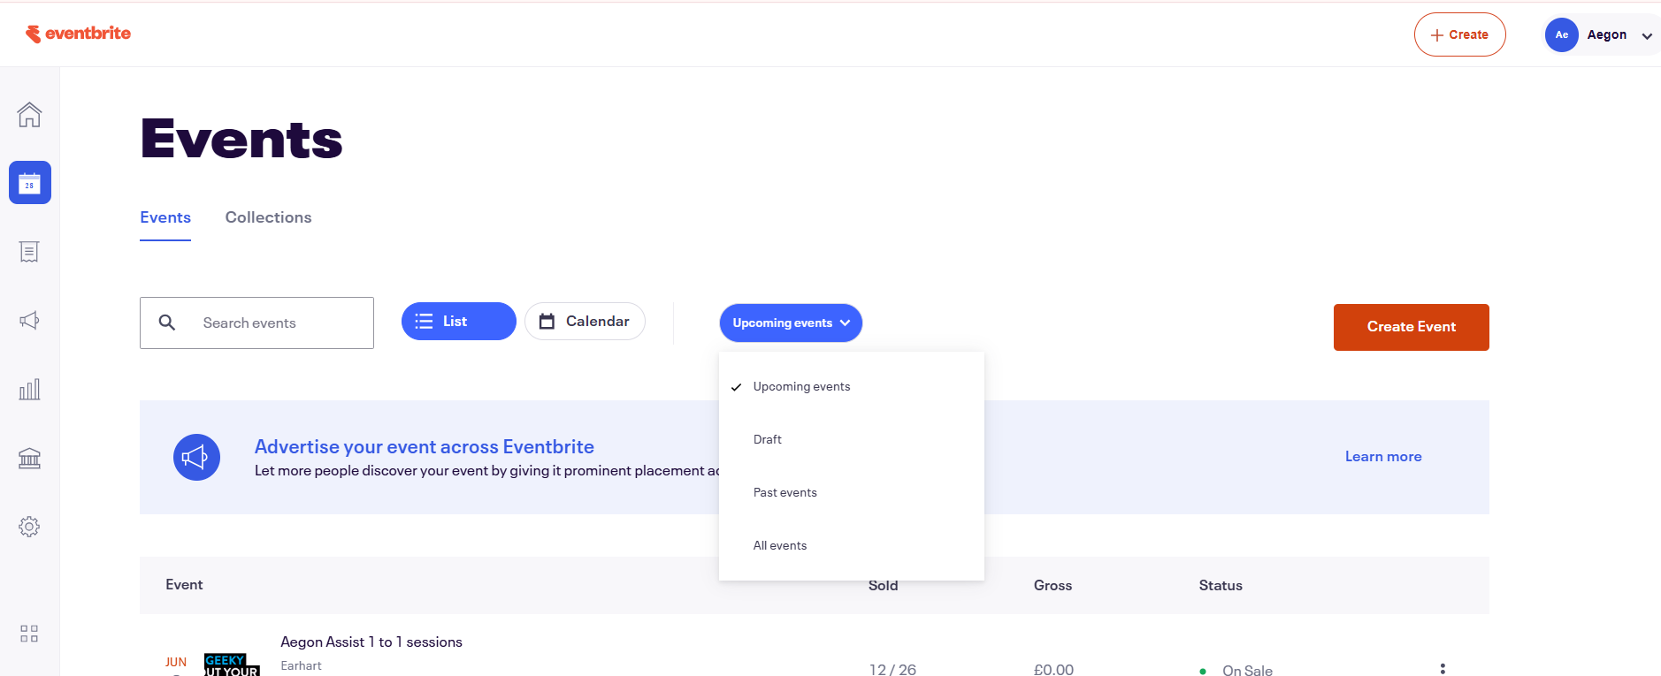
All Aegon events are private by default — ensure this setting is maintained when creating new events.

3. Creating a New Event
If a similar event already exists, use the “Copy” function (three dots menu) to duplicate it.
Update the following:
- Title
- Summary
- Start/End Dates
Follow the step-by-step interface to complete event setup.

4. Event Details
Venue Type:
- For in-person events: enter venue details.
- For online events: select “Online” and input the Microsoft Teams link (not Zoom).
  - Add optional details like:
- Agenda
- Speaker Info
- Overview Text
- Event banner (either created via APS, used from a previous event) - Event banners must be 1080x2160.
Example event can be found under drafts:
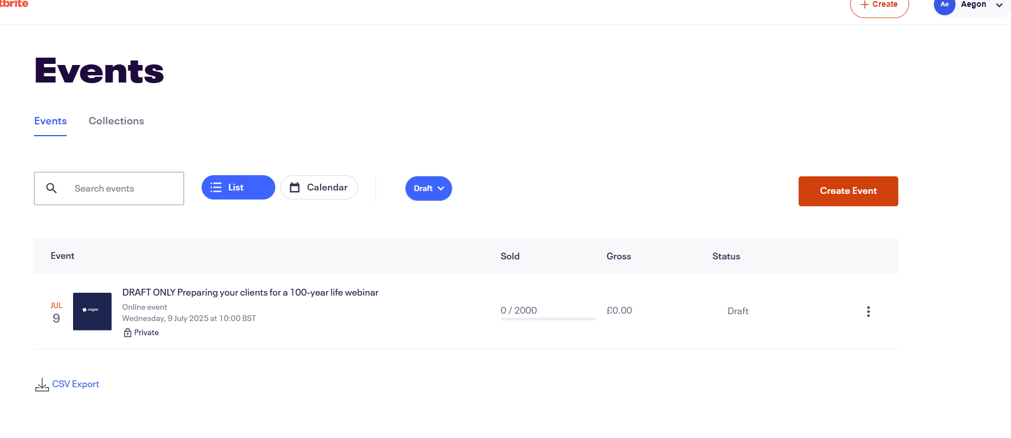

5. Ticketing
All tickets are generally free. Internal events for charity committee has used paid tickets and can be set up using the following options
Most tickets are free. Paid tickets (e.g., for internal charity events) can be configured:
Price: Set ticket price.
- Absorb Fees: Choose whether Aegon or the attendee pays Eventbrite fees, further information can be found here.
- Payouts are sent three days after the event or can be scheduled earlier.
Set ticket quantity based on expected attendance or room capacity, generally live events 2000 – 3000. You can edit ticket numbers later if required.

You can edit ticket numbers later if needed further guidance on ticket set up can be found here.

6. Order Form (Optional)
To collect attendee details (e.g., firm, phone number), go to:
Order Options → Order Form
Add custom questions and mark them as required or optional.

7. Event Visibility
Always set events to Private.
Use “Anyone with the link” access — no password protection is typically required.

8. Collections (Optional)
Use Collections to group related events (e.g., Pension Geeks series).
Add a title, subheading, image, and link relevant events.

9. Emails to attendees (Optional)
We don’t typically send emails to attendees however in instance of change in circumstances or further engagement emails can be sent to all attendees, if required the following steps;
- 1. Go to your event dashboard.
- 2. Go to "Emails to attendees" (under “Manage attendees”).
- 3. Create your email.
- 4. Send a test email – upload to MOS for proof.
- 5. Choose when and who to send your email to.
Follow the Eventbrite guidance here for further tips.

10. Reporting & Attendee Lists
Access attendee data via:
- The event page → “Attendee List” (PDF download).
- The Reporting tab → export Excel reports.
Customise the Order Form to collect additional data (e.g., job title, organisation).
Eventbrite sends out email communications for order confirmations, cancellations and general updates this means you will receive emails for other stakeholders events unfortunately there is no way to turn this on/off per individual event, however you can manage this within communication preferences within your account and check the event as a standalone for updates on orders.
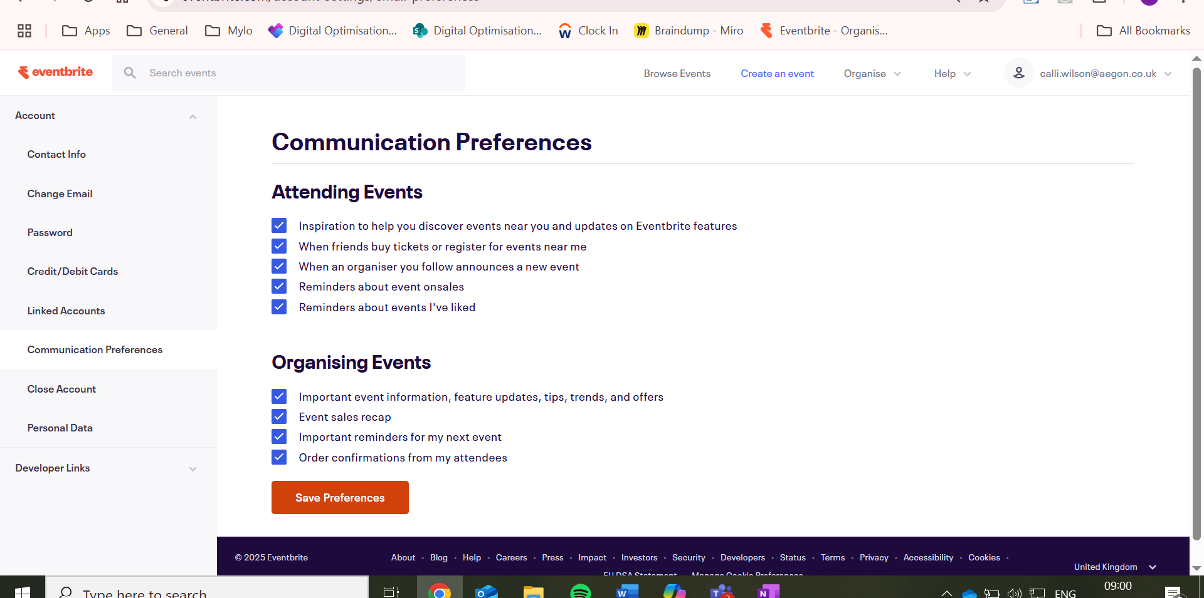

11. Troubleshooting & Support
If you encounter issues:
- Try refreshing or re-accessing the platform.
- Use Eventbrite’s help resources or reach out to a team member.
Note: Eventbrite updates its interface frequently — some features may move or change.

